**DAILY ONLINE ACTIVITIES SUMMARY**

|  |  |  |  |  |
| --- | --- | --- | --- | --- |
| **Date:** | | **03-06-2020** | **Name:** | **Latika Kavoor** |
| **Sem & Sec** | | **4th Sem & A-Section** | **USN:** | **4AL18CS035** |
| **Online Test Summary** | | | | |
| **Subject** | **OOC** | | | |
| **Max. Marks** | **30** | | **Score** | **12** |
| **Certification Course Summary** | | | | |
| **Course** | | **Machine Learning Onramp** | | |
| **Certificate Provider** | | **MATHWORK** | **Duration** | **3 hrs** |
| **Coding Challenges** | | | | |
| **Problem Statement:** Write a Java program to find Last Digit of a^b (a to the power b) for Large Numbers  You are given two integer numbers, the base a (number of digits d, such that 1 <= d <= 1000) and the index b (0 <= b  <= 922*10^15). You have to find the last digit of a^b.  Examples:  Input : 3 10  Output : 9  Input : 6 2  Output : 6  Algorithm  Algorithm :  1.Since number are very large we store them as a string.  2.Take last digit in base a.  3.Now calculate b%4. Here b is very large.  -> If b%4==0 that means b is completely divisible by 4, so our exponent now will be exp = 4  because by multiplying number 4 times, we get the last digit according to cycle table in  above diagram.  ->If b%4!=0 that means b is not completely divisible by 4, so our exponent now will be  exp=b%4 because by multiplying number exponent times, we get the last digit according to  cycle table in above diagram.  -> Now calculate digit = pow( last_digit_in_base, exp ).  ->Last digit of a^b will be ldigit%10 | | | | |
| **Status: Completed** | | | | |
| **Uploaded the report in Github** | | | **Yes** | |
| **If yes Repository name** | | | <https://github.com/alvas-education-foundation/latika.kavoor/tree/master/coding_solutions> | |
| **Uploaded the report in slack** | | | **Yes** | |

Online Test Details: (Attach the snapshot and briefly write the report for the same)

OOC Test 3 conducted as on 03-06-2020 was for 30 marks from 9:15am onwards.There were 30 questions for 1 mark each.The question type was more of guessing the output of the program given in the question.

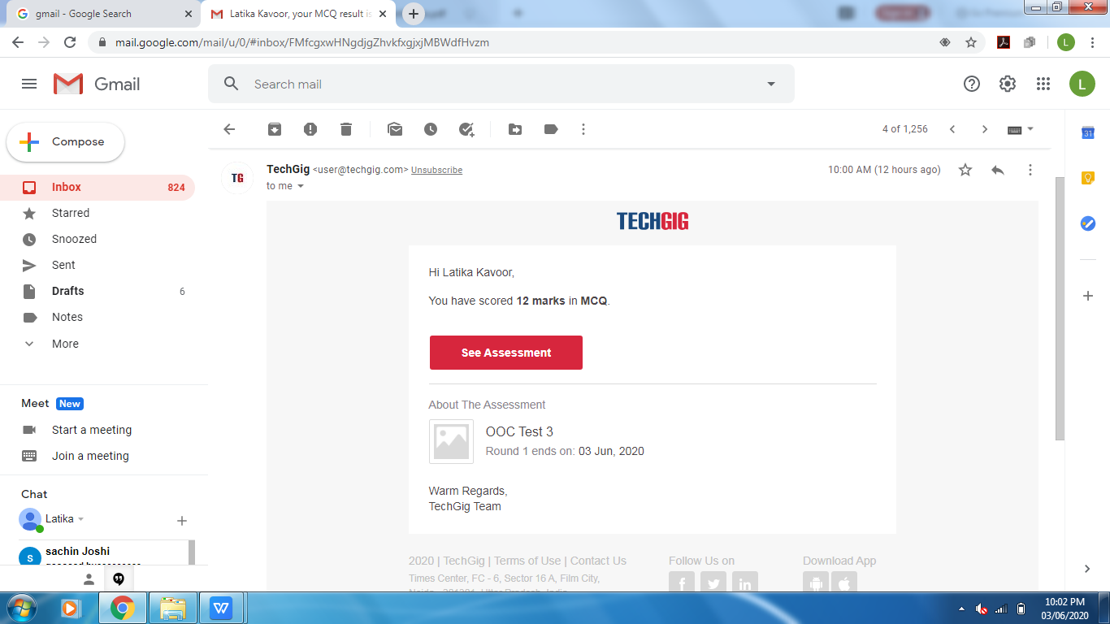

Certification Course Details: (Attach the snapshot and briefly write the report for the same)

I started with MACHINE LEARNING ONRAMP course provided by MATHWORK. It is a 3 hours course and there were problems and tasks to be solved in it. I am almost going to complete the course and will upload the certificate by tomm.

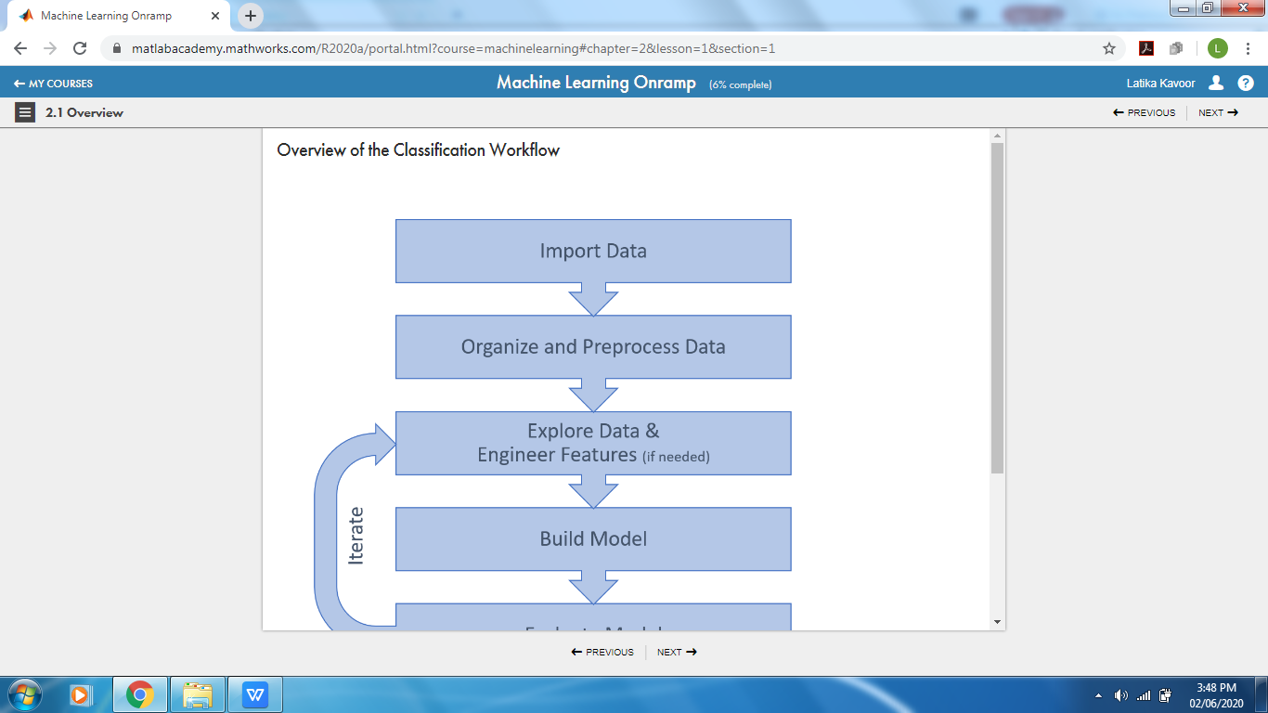

Coding Challenges Details: (Attach the snapshot and briefly write the report for the same)

Solved the problem and uploaded the same on github

